**WCA & NASW Wyoming**

**Joint Conference**

***“New Perspectives on Wellness”***

***September 20-22, 2018***

**Request for Student Poster Session Proposals**

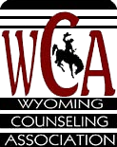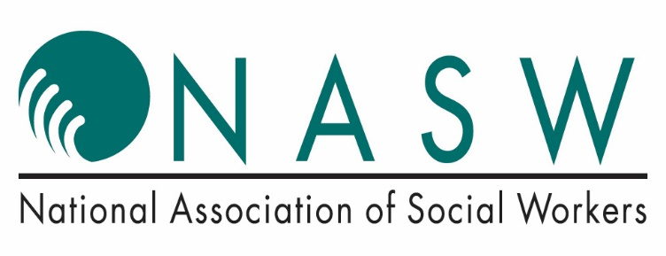

**All proposals should be submitted prior to AUGUST 1, 2018**

[**http://www.wyomingcounselingassociation.com/student-poster-proposals/**](http://www.wyomingcounselingassociation.com/student-poster-proposals/)

*Visit the WCA (www.wyomingcounselingassociation.com) or NASW Wyoming (www.wyomingnasw.com/home.html) website to learn more about the conference.*

**Share Your Knowledge, Innovative Solutions, Strategies, and Experiences at the WCA and NASW Joint Conference.**

The purpose is to bring attention to the efforts of aspiring counselors and social workers and share what’s currently happening in the field. Posters are encouraged from current Bachelors and Masters level students and recent graduates.

**Inviting proposals related to…**

* Innovative counseling programs, research projects, and activities that address and/or have been successfully implemented in a variety of settings.
* Collaborative, creative, and effective strategies/best practices for meeting the needs of clients in a variety of settings.
* Effective techniques used to address societal concerns and current issues, including returning military, economically disadvantaged populations, and specific populations.
* Programs with a special tie to our state or region.
* Specific skills, techniques and activities, which can be applied immediately after the conference

**What is a poster session?**

Poster sessions are a forum for the exchange of information among conference attendees. They take place outside the programmed workshop sessions and are a way to communicate ideas, research and programs. Information is communicated via text, graphics, tables, charts, pictures, and verbal descriptions with the aim of presenting highlights of a program or research study. Students generally stand by posters during the time they are displayed and participate in discussion of their poster material.

**Eligibility and Requirements**

* Open to students currently enrolled in a BSW, addictions, or graduate (social work & counseling) program and recent graduates. (*Other disciplines considered on a case-by-case basis.*)
* Posters may be either (1) Original research, or (2) Critical commentary on relevant topics
* Individuals can submit **one** proposal including abstract detailing the research or concept.
* Poster presenter must be the primary author. Input/support from a faculty member is  encouraged.
* Poster presenters are responsible for the set up and take down of their posters.

**Proposal Submissions**

**CONTACT INFORMATION:** Provide the following information for the LEAD PRESENTER.

Communication regarding the proposal and/or any questions will be with this individual.

* Name and School
* Preferred phone and email contact information
* A brief biography (3-4 sentences) to be used for introductions and in printed materials.
* Presentation Title and a brief Abstract/Description to be used in printed materials.

**POSTER SETUP:** Presenters will be provided with an easel. Posters should be professional with printed text. Recommended size for each poster is 48"x 36".