**Wyoming Counseling Association**

*Heal the Healer Summer Retreat*

August 3-5, 2018

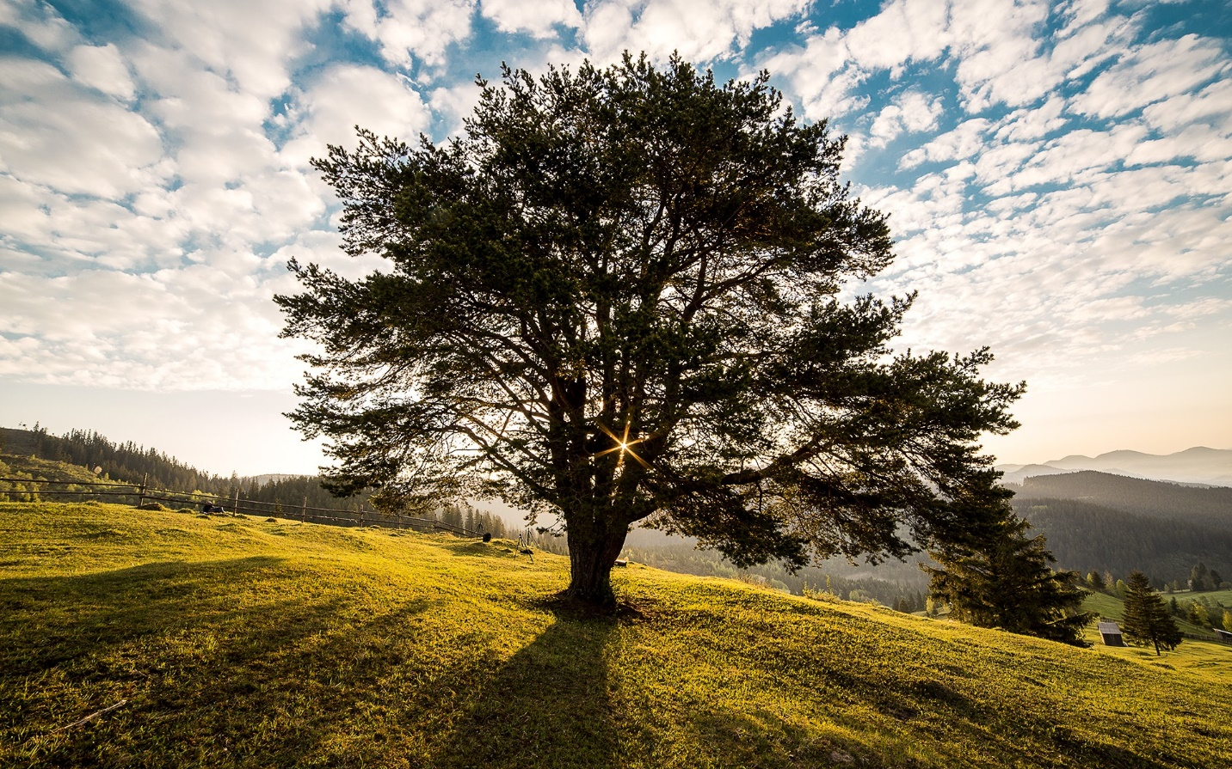

Camp Sacajawea on Casper Mountain

Casper, WY

|  |
| --- |
| **Registration Rates** |
| Presenters/Students/Retirees = $130  Members & Associate Members = $175  Non-Members = $235  After July 15 = Add $50  *No registrations accepted after July 27 |

Join fellow counselors for a weekend of self-care, nature, and community building with low-tech CE workshops. Visit <http://www.wyomingcounselingassociation.com/> for more information.

*8 CE credits available*